AULA DO DIA 21/05 – VIBE CODING EXECUTIVO
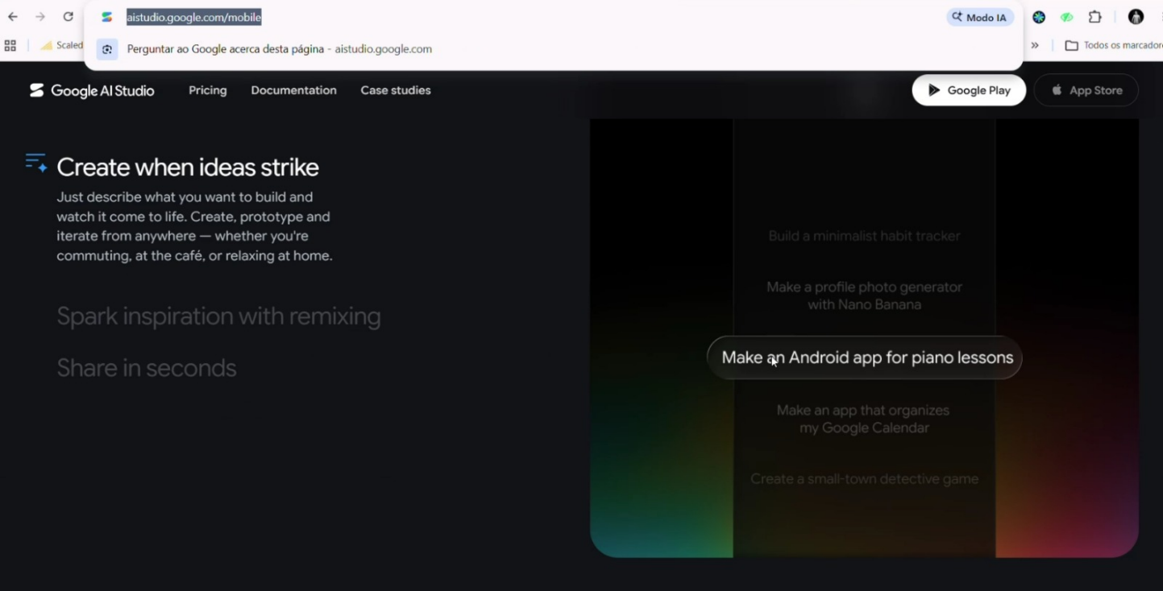
https://aistudio.google.com/mobile
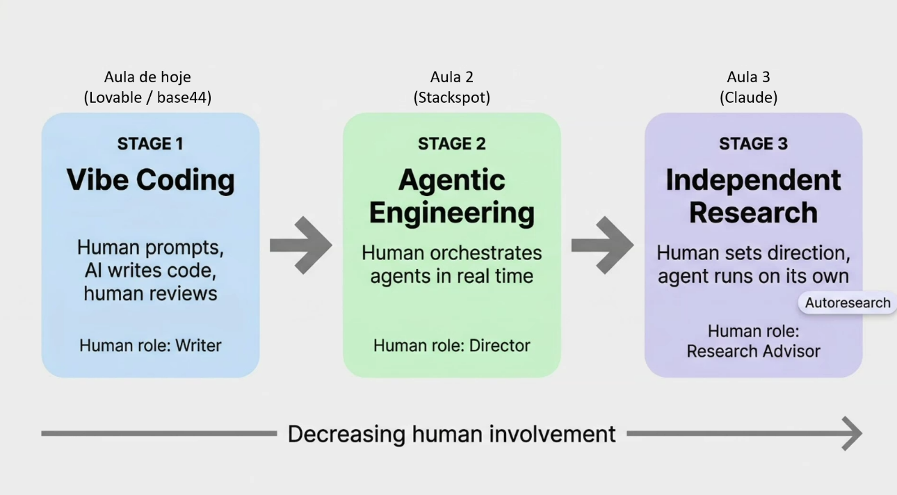
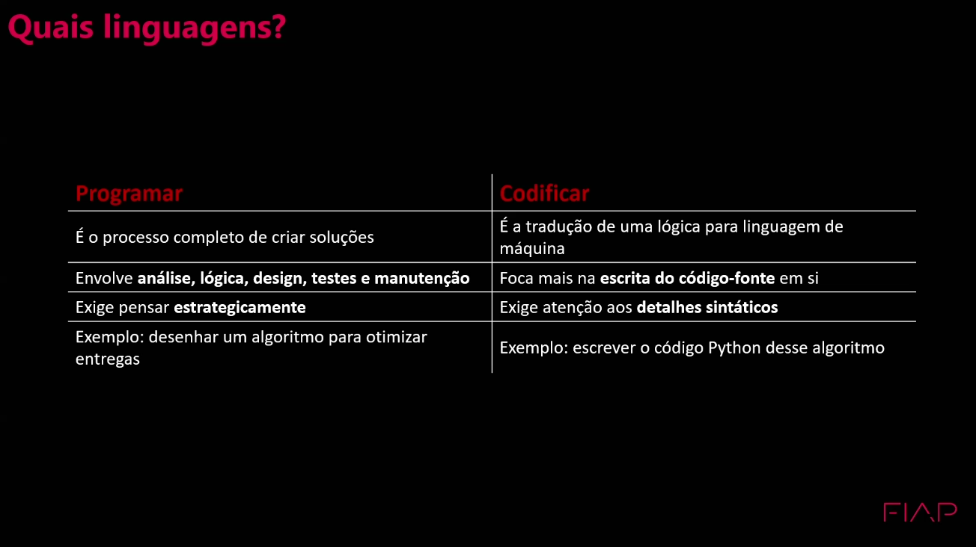
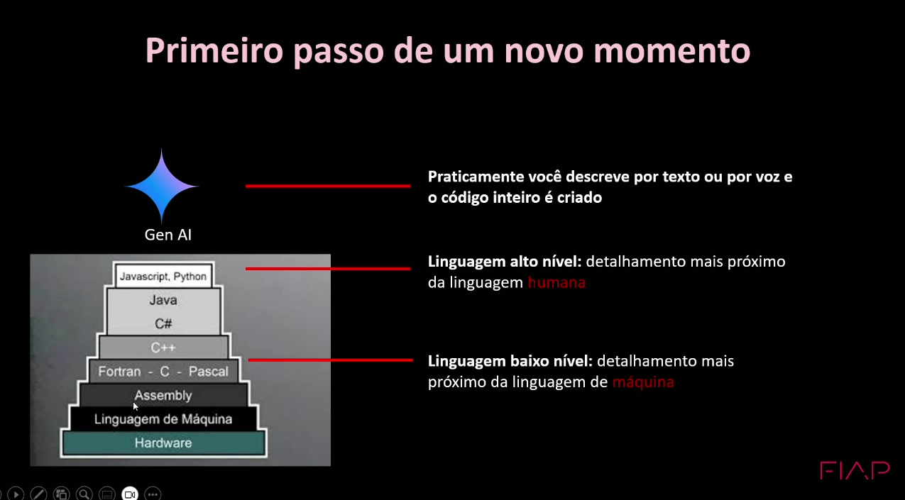+
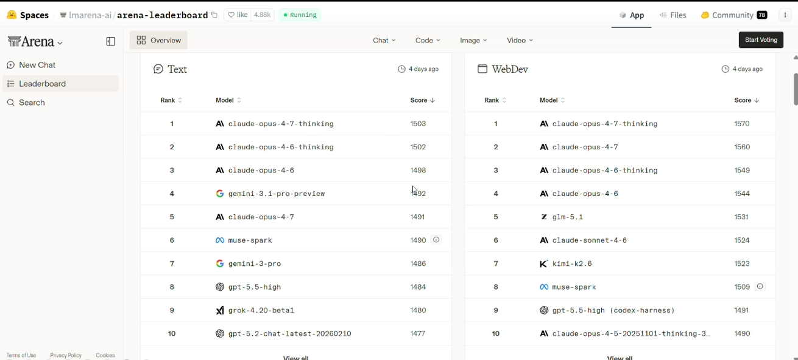
https://huggingface.co/spaces/lmarena-ai/arena-leaderboard

